**Ishita Barnawal**

**18mca1013**

JDBC Study Experiment

**package** mypack;

**import** java.sql.*;

**import** javax.swing.JOptionPane;

**import** java.io.*;

**public** **class** JDbc

{

**public** **static** **void** main(String[] args)

{

String url="jdbc:oracle:thin:@localhost:1521:XE";

**try**

{

Class.*forName*("oracle.jdbc.driver.OracleDriver");

System.***out***.println("Driver is loaded");

Connection connection=DriverManager.*getConnection*(url,"system","oracle");

System.***out***.println("Connection establish");

String sql="update student set name=?,year=?,course=?,semester=? where reg_no=?";

PreparedStatement pst=connection.prepareStatement(sql);

pst.setString(1, "RAMAN");

pst.setString(2,"2030");

pst.setString(3,"MCA");

pst.setString(4,"3");

pst.setString(5,"18mca1094");

pst.executeUpdate();

System.***out***.println("Update Sucessfull");

//all related work

connection.close();

}

**catch**(ClassNotFoundException e)

{

System.***out***.println("Driver not loaded");

}

**catch**(SQLException e)

{

System.***out***.println("Connection not establish");

}

}

}

Output

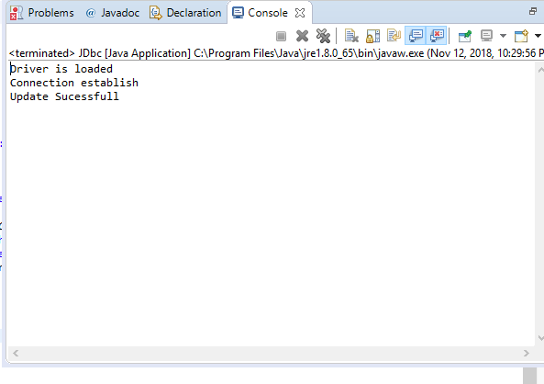

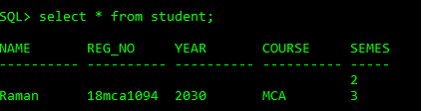

**Steps to connect to jdbc:**

